**MIS 304 Chapter 4 exercises**

*Setup for the assignment*

*The assignment for this chapter has two parts. 1) Setup a SWOT analysis for a company you work for now or have worked for in the past. If you haven’t had job that will permit a SWOT analysis, then use Oregon Tech as your organization to analyze. Look at the accompanying example to the level of the SWOT requested. 2) Use your quantitative skills to solve the four questions below. Show your work and provide an explanation. Just providing an answer is not the assignment.*

*Please embed your SWOT analysis within your single Word doc submitted for this assignment. Be sure to address each of the questions below in addition to your thoughtful explanation of your SWOT analysis.*

**Section 1: SWOT analysis**

The organization/company that I will be discussing is my previous employer Work Truck Direct. Work truck direct is supported, owned, and operated by its parent company AP Financing. Work truck direct is tasked with being the middleman between work truck manufacturers/providers and the customers that want them. This is achieved by Work truck direct finding customers that are often tradesman who need trucks but don’t want to buy them. So, work truck direct purchases the trucks that the customers need and then leases them to the customers along with maintaining there working order. Right now, work truck direct is just starting out so their active customer base is small compared to larger equipment companies. This means that there are only 20 or so employees that are mostly salesman and marketers.

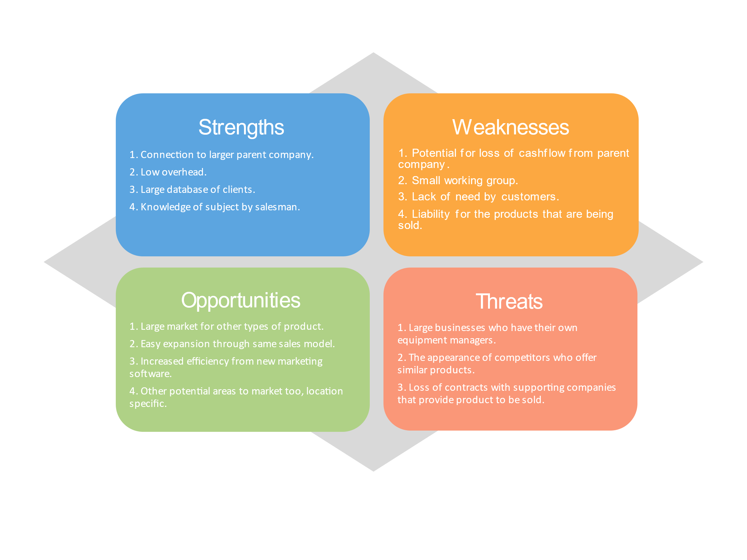

**STRENGTHS**

1.Connection to larger parent company:

Work truck direct is owned and operated by AP Financing which enables them to share capital among there different businesses but also share resources.

2. Low overhead:

The business itself only has one place of location that only includes 20 employees. All product is brought in from another business so there are no operating costs for making the product or storing it.

3. Large database of clients:

After many years of trade shows and searching for clients the Work truck direct database has 10’s of thousands of potential small business clients. Then there are several current large clients such as FedEx and UPS which bring in current capital.

4. Knowledge of subject by salesman:

All the salesman that work for the company were hired for their context of selling work trucks to business clients that need them. They have knowledge that allows them to represent the business well along with giving the customer good information.

**OPPORTUNITES**

1.Large market for other types of product.

Right now, Work Truck Direct is focusing on selling work trucks to tradesman like plumbers and water damage cleanup companies and businesses. This is just a small portion of the market that uses work trucks the potential to expand to all tradesman and large trade companies is there for the taking.

2. Easy expansion through same sales model.

The sales model of being the middleman between the work truck builders and the trade businesses will work on a variety of businesses with similar systems, all that would need to change is the client lists.

3. Increased efficiency from new marketing software.

With new marketing software that enables careful planning and the ability to reach customers more efficiently the business could increase efficiency and profit.

4. Other potential areas to market too, location specific.

The area that Work Truck Direct salesman currently market too is very specific to central and southern California. This area could be expanded easily because you don’t need salesman in the actual state. All that is needed is work truck providers that are willing to ship to that location.

**WEAKNESSES**

1.Potential for loss of cashflow from parent company.

If resources from the parent company have to be transitioned to another one of their venters the possibility for limited funds could create a problem for expansion.

2. Small working group.

The current number of salesman and marketing employees is very small and if expansion into other states and more clients ever occurs many more employees would have to be hired and found with the necessary skills.

3. Lack of need by customers.

The entire business relies on customers needing someone to lease and handle their truck fleet. If those businesses decided to purchase their own trucks or go around the company and purchase the trucks from the manufacture, there could be a loss in customer base.

4. Liability for the products that are being sold.

Since the company is leasing the trucks to their customers, they have liability that needs to be handled. Potential damage that can happen along with problems with the trucks when they get to the customer. This means that employees and managers need to be there to take care of these issues when they happen.

**THREATS**

Large businesses who have their own equipment managers.

Some companies like Amazon who are just starting to get into work trucks to deliver there packages instead of USPS or UPS have their own fleets. This means that they have no need for companies like Work Truck Direct. If large companies like this get similar ideas a huge part of the market will disappear.

2. The appearance of competitors who offer similar products.

Right now, the market does not have many competitors but if another busines is created that has similar ideas, and possibly better deals with truck manufacturers they could grab up the market.

3. Loss of contracts with supporting companies that provide product to be sold.

If there are contract disputes and or problems with the manufacturing side of things or even the customers, then there could be huge losses. For example, Work truck direct has a contract with UPS that brings in a large amount of their income from a single source. If that were to disappear then they would either have to find another large business with similar needs or find many smaller customers to make up the difference.

**Section 2: Quantitative Analysis**

**Q 1 of 4**

Q: Sales of a particular product (in thousands of dollars) for the years 2009 through 2012 have been 48, 64, 67, and 83, respectively. a) What sales would you predict for 2013 using a simple four-year moving average? (b) What sales would you predict for 2013 using a weighted moving average with weights of 0.50 for the immediately preceding year and 0.30, 0.15, and 0.05 for the three years before that?

(a) Simple moving average: 65.5 (48 + 64 + 67 + 83)/4

(b) Weighted moving average: 73.6 (48*0.05) + (64*0.15) + (67*0.30) + (83*0.50)

**Q 2 of 4**

Q: Using exponential smoothing with a weight ex of 0.6 on actual values: (a) if sales are $45,000 and $50,000 for 2010 and 2011, what would you forecast for 2012? (b) given this forecast and actual 2012 sales of $53,000, what would you then forecast for 20013?

(a) 48000

(b) 51000

**Q 3 of 4**

Q: In Question 2 of 4, taking actual 2009 sales of $48,000 as the forecast for 2010, what sales would you forecast for 2011, 2012, and 2013 using exponential smoothing and a weight **α** based on actual values of (a) 0.4; (b) 0.8?

(a) **α** = 0.4: There’s only one data point??? That’s not enough for a forecast

(b) **α** = 0.8: There’s only one data point??? That’s not enough for a forecast

**Q 4 of 4**

In Question 2 of 4, what sales would you forecast for 2013 using the simple regression (least squares) method?

I have no idea what this question is asking for. Do you mean “Use the data from 2 of 4 to figure out what 2013 would be using a simple regression”?